

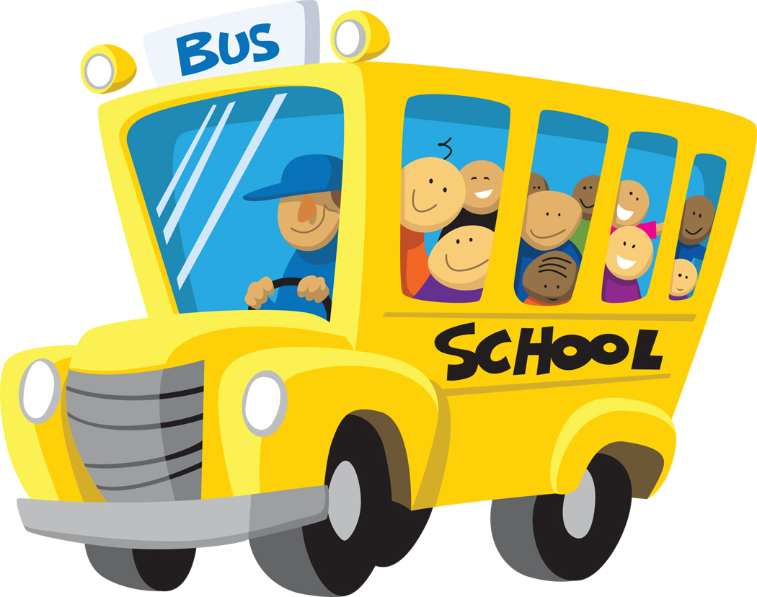



# Norcross Elementary School September 2013

**Read a Book this Month**

**September** is [Library Card Sign-up Month](https://www.ala.org/ala/aboutala/offices/pio/mediarelationsa/factsheets/librarycardsign.cfm). Make your library card the most valuable card in your wallet!

For more information

please visit

[www.atyourlibrary.org](http://www.atyourlibrary.org)

**Read For Change**

Everyone should read to or with a child. It is known to make a difference to a child's learning. So, start reading with your child today. Spend some time together to build your child's literacy skills and impact their future! ***Readers Rock the World!***

### Literary Birthdays

##### Eugene Field September 2

##### <http://www.selfknowledge.com/146au.htm>

##### Aliki Brandenberg September 3

##### <http://people.ucalgary.ca/~dkbrown/k6/aliki.html>

##### Jack Prelutsky September 8 <http://www.kidsreads.com/authors/au-prelutsky-jack.asp>

##### Roald Dahl September 13

##### [www.roalddahl.com](http://www.roalddahl.com)

##### Tomie DePaola September 15

##### [www.tomie.com](http://www.tomie.com)

##### Robert McCloskey September 15 <http://childrensbooks.about.com/cs/picturebooks/a/mccloskey.htm>

##### H. A. Rey September 16

##### <http://www.houghtonmifflinbooks.com/features/cgsite/>

##### Shel Silverstein September 25

##### [www.shelsilverstein.com](http://www.shelsilverstein.com)

##### Kate Douglas Wiggins September 28 <http://www.fantasticfiction.co.uk/w/kate-douglas-wiggin/>

##### Stan Berenstain September 29

##### [www.berenstainbears.com](http://www.berenstainbears.com)

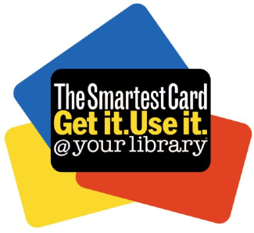

*Did you know?*

On September 4, 1888 the   
1st roll film camera patented.

On September 8, 1892 was the

first reading of the Pledge of Allegiance.

On September 10, 1846 the   
sewing machine was patented.

On September 12, 1959 the

Russians launched the first

rocket to the moon.

On September 20, 1519 Magellan began search for passage to India.

C:\Documents and Settings\judy serritella\Local Settings\Temporary Internet Files\Content.IE5\958HE81V\MC900322784[1].wmf

C:\Documents and Settings\judy serritella\Local Settings\Temporary Internet Files\Content.IE5\958HE81V\MC900322784[1].wmf

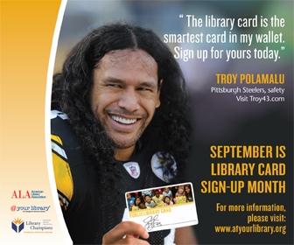



MCj03666420000[1]

C:\Documents and Settings\e198705932\Local Settings\Temporary Internet Files\Content.IE5\72FD5HI2\MCj00892160000[1].wmf

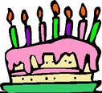

**Between the Lions** is on PBS stations around the country. Check it out. <http://pbskids.org/lions/>

C:\Documents and Settings\judy serritella\Local Settings\Temporary Internet Files\Content.IE5\958HE81V\MC900232792[1].wmf

**Any book that helps a child to form a habit of reading, to make reading one of his deep and continuing needs, is good for him.**

**~ Maya Angelou**

