

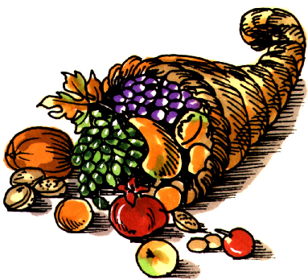

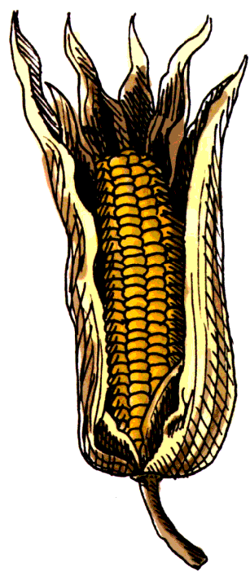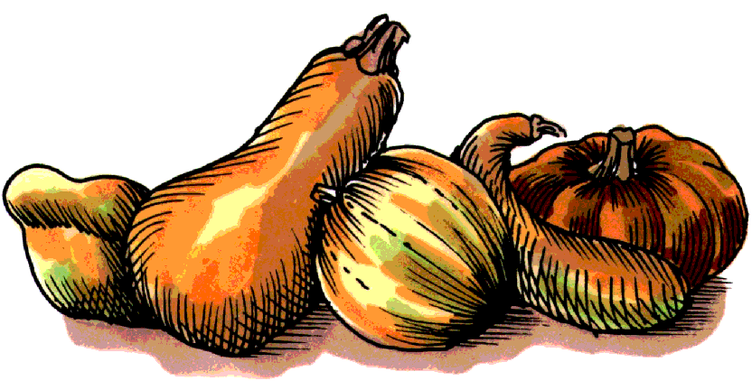

# Norcross Elementary School November 2013



MCj04241780000[1]

#### Extra, extra, read all about it!

Check out the 2013 Children’s Choices booklist from the International Reading Association

and the Children’s Book Council. Some

choices this year include:

**Beginning Readers (Grades K–2)**

*Big Mean Mike* by Michelle Knudsen

*The Duckling Gets a Cookie!?* by Mo Willems

*I’ll Save You Bobo!* by Eileen Rosenthal

*Nighttime Ninja* by Barbara DaCosta

*Pete the Cat and His Four Groovy Buttons* by Eric Litwin

**Young Readers (Grades 3–4)**

*Bad Kitty for President* by Nick Bruel

*Get the Scoop on Animal Poop!* by Dane deGroat

*Just Joking: 300 Hilarious Jokes...* National Geographic

*Pluto Visits Earth!* by Steve Metzger

**Advanced Readers (Grades 5–6)**

*Dork Diaries 4* by Rachel Renée Russell

*Liar & Spy* by Rebecca Stead

*Pickle: The (Formerly) Anonymous Prank Club of Fountain Point Middle School* by Kim Baker

*Rebel McKenzie* by Candice Ransom

*Stickman Odyssey, Book 2* by Christopher Ford

To see the entire list go to: <http://www.reading.org/Libraries/choices/ira-cbc-childrens-choices-reading-list-2013.pdf>

**Internet Safety Tip**

**Is your child’s computer**

**in his room?**

**Move the computer to a common area in the house where a caring adult can monitor his use.**

### Literary Birthdays

**Robert Louis Stevenson November 13**

Author of *Treasure Island* and other adventure novels

<http://www.best-books-for-kids.com/robert-louis-stevenson.html>

**William Steig November 14**

Cartoonist, illustrator, and award-winning author

<http://us.macmillan.com/author/williamsteig>

**Marc Brown November 25**

Author of the *Arthur* books series

<http://marcbrownstudios.com/>

**Tomi Ungerer November 28**

Award-winning illustrator

<http://www.tomiungerer.com/>

**Madeleine L’Engle November 29**

Author of *A Wrinkle in Time*

<http://www.madeleinelengle.com/>

**C.S Lewis November 29**

Author of *The Lion the Witch, and the Wardrobe* series

<http://cslewis.drzeus.net/>

**Margot Zemach November 29**

Caldecott Medal winning illustrator

<http://www.embracingthechild.com/azemach.html>

**Charles Schulz November 29**

Wrote the *Peanuts* cartoons and books

<http://www.universaluclick.com/comics/peanuts/>



There are many little ways to enlarge your child’s world. Love of books is best of all. ~ Jacqueline Kennedy

##### What’s Happening?

The newest Wimpy Kid

book will be available

on November 4th!

*Diary of a Wimpy Kid:*

*Hard Luck*

by Jeff Kinney will be

available in stores

soon.

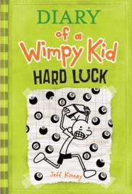

One of the greatest gift adults can give to their offspring and to their society is to read to children. ~ Carl Sagan

Who is Carl Sagan? Use *Britannica Biographies* to do research on this person.